Kalyani Government Engineering College
FPGA Implementation Of Digital Circuits Using VHDL

A PROJECT REPORT
Submitted by
Kanchan Kumar Kaity (10200320005)
Anjisnu Chanda (10200320007)
Dhiraj Chandra (10200320019)
Debjyoti Sardar (10200320020)

Guide : Dwaipayan Ghosh
BACHELOR OF ENGINEERING
In
ELECTRONICS AND COMMUNICATION ENGINEERING

Abstract :

In this project we implemented a 8-bit ALU VHDL code in a Xilinx Spartan 3e XC3S50 FPGA kit.
An FPGA (Field-Programmable Gate Array) board is a type of electronic circuit board that contains an FPGA chip, which is a programmable digital logic device. FPGAs can be reprogrammed to desired application or functionality requirements after manufacturing.
Due to their programmable nature, FPGAs are an ideal fit for many different markets, including digital signal processing, image processing, cryptography, and data center acceleration.
Throughout our entire project we design a 8 bit ALU (Arithmetic-Logic Unit) where when we have to enter our respective values and then select the operation to be performed, the decoder then decodes the respective operation to be performed on our given values, we will go through the various operations throughout our project in details.

Contents:
- Introduction
  - What is ALU
  - What is FPGA
- Operations in ALU
  - Arithmetic Operations:
    - Addition
    - Subtraction
    - Multiplication
    - Division
    - Shift Left
2.1.6 Shift Right
2.2 Logical Operations:
2.2.1 AND
2.2.2 OR
2.2.3 NOT
2.2.4 NAND
2.2.5 NOR
2.2.6 XOR
2.2.7 XNOR
2.2.8 Buffer
3. Structures
3.1 Structure of the ALU
3.2 Structure of the Decoder
4. Codes For Operations
5. Results Of Operations
  - Addition 5.9 NOT
  - Subtraction 5.10 NAND
  - Multiplication 5.11 NOR
  - Division 5.12 XOR
  - Shift Left 5.13 XNOR
  - Shift Right 5.14 BUFFER
  - AND
  - OR
- Introduction
Contrary to appearances, there is some overlap between software engineering and hardware engineering. The gap between programming software and programming hardware is filled by devices known as field-programmable gate arrays (FPGAs), whose physical characteristics can be modified through the use of hardware description languages (HDLs).
  - ALU
An Arithmetic and Logic Unit (ALU) is a digital circuit that performs arithmetic and logical operations on input data. It is a fundamental component of a central processing unit (CPU) in a computer. The arithmetic operations performed by an ALU include addition, subtraction, multiplication, and division. The logical operations include bitwise operations such as AND, OR, XOR, and NOT. Here, we have also included the shift left and shift right operations. The ALU receives two input values, performs the desired operation on those values, and produces a single output value. The output value is then passed on to other parts of the CPU or the computer system.
The performance of the ALU is a key factor in determining the overall speed and efficiency of a computer system.
  - FPGA
FPGAs are integrated circuits (ICs) that fall under the umbrella of programmable logic devices (PLDs). The fundamental functionality of FPGA technology is built on adaptive hardware, which has the unique ability to be modified after manufacture. Arrays of hardware blocks, each configurable, can be connected as needed, allowing highly efficient, domain-specific architectures to be built for any application. FPGA boards are used for a wide range of applications, including digital signal processing, image processing, cryptography, and data center acceleration. FPGA boards typically include various input/output (I/O) interfaces, such as USB, Ethernet, and HDMI, as well as additional components such as memory and sensors. Some FPGA boards also have built-in processors, such as ARM processors, to provide additional processing capabilities. FPGA boards are popular for prototyping and developing custom digital circuits and systems because they allow engineers and designers to program and reprogram the logic of the FPGA chip to create custom hardware solutions. This flexibility makes them particularly useful for applications that require high performance, low latency, or low power consumption

- Operations in ALU

The following are the operations that our designed ALU can perform:

  - Arithmetic Operations:
1.Addition
2.Subtraction
3.Multiplication
4.Division
5.Shift Left
6.Shift Right

  - Logical Operations:

- AND
- OR
- NOT
- NAND
- NOR
- XOR
- XNOR
- Buffer

  - Arithmetic Operations:

    - Addition:
This ALU can perform 8 Bit Addition. To perform the addition, we start from the rightmost bit (the least significant bit) and work our way to the left, adding each corresponding pair of bits and carrying over any carry values. The additions are performed through Full Adder. The components involved in the addition are 8 1-Bit Full Adder.
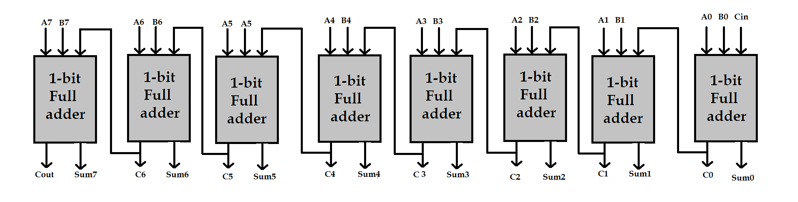
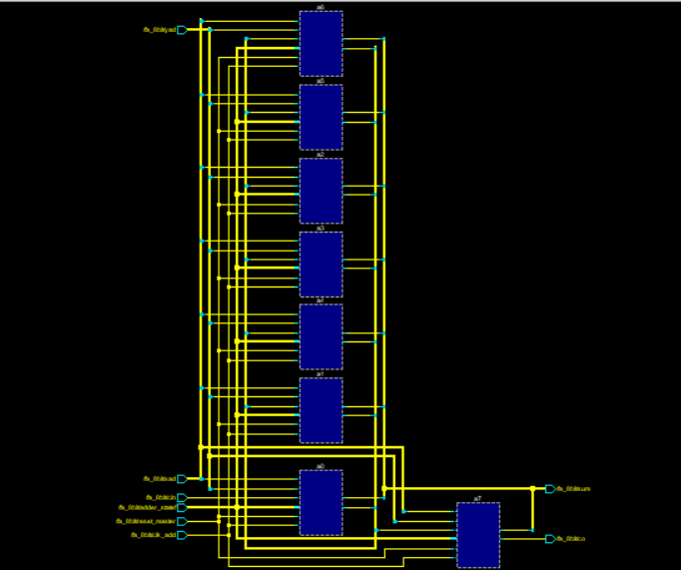

2.1.2 Subtraction :
This ALU is designed to perform 8 Bit Subtraction. At first binary subtraction is performed on the LSB. In subtraction if 0 is subtracted from 1 then a borrow is generated which is then carry forwarded to the next bit for subtraction. The subtractions are performed through Full Subtractor. The components involved in the subtraction are.
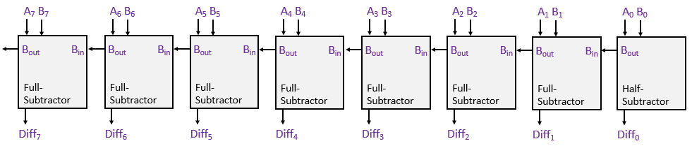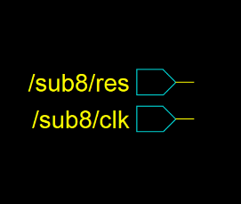
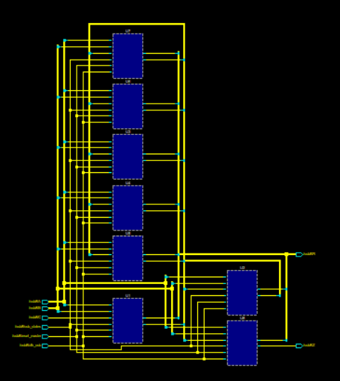

2.1.3 Multiplication :
Unlike basic ALUs, our ALU is designed to perform multiplication directly. It follows the concept of Array Multiplier where it employs an array of logic gates, typically AND gates and adders, to compute the partial products and then accumulate them to obtain the final product. The result is finally stored and obtained through the simulation. The components involved in the multiplication are
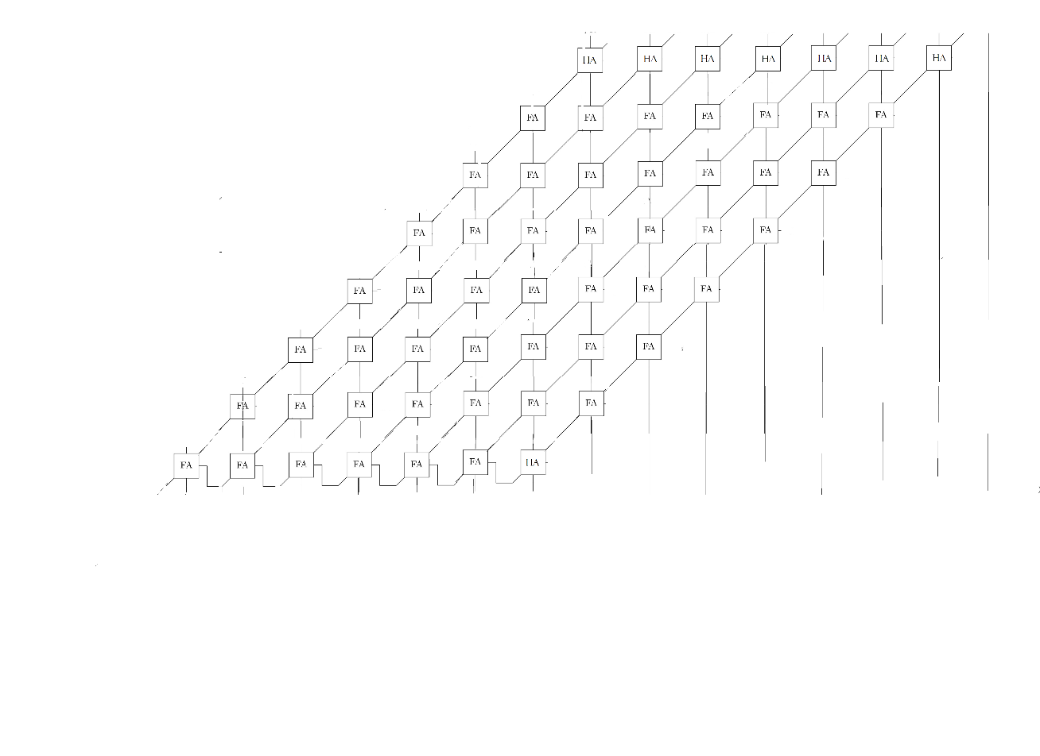
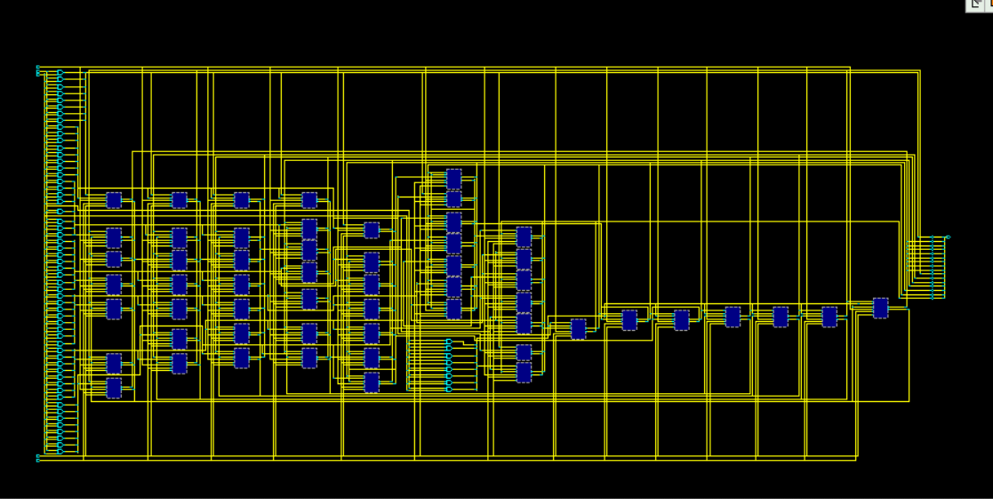
2.1.4 Division
This ALU can also perform division directly by following the algorithm of repetitive subtraction. Repetitive Subtraction involves subtracting the divisor repeatedly from the dividend until the result is zero or a number smaller than the divisor is obtained. The number of subtractions performed gives the quotient, and the remaining number (if any) is the remainder. The components involved in the division are.
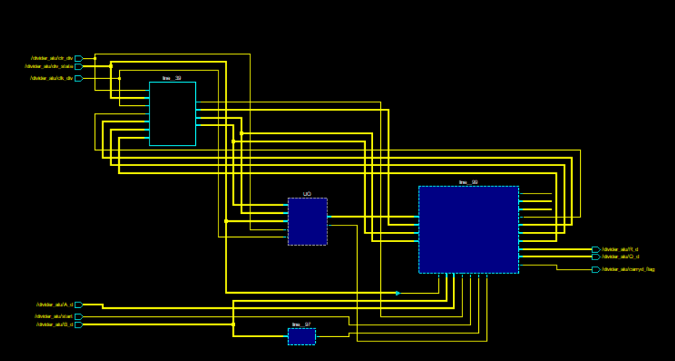

2.1 Shift Operation
Binary shift operations are bitwise operations that shift the bits of a binary number to the left or right. These operations are commonly used in low-level programming, such as when working with binary representations of data or performing optimizations on integer arithmetic.
There are two types of binary shift operations:
2.1.5 Left Shift (<<): The left shift operation shifts the bits of a binary number to the left by a specified number of positions. The leftmost bits are discarded, and new bits are introduced on the right side, with zero values.
2.1.6 Right Shift (>>): The right shift operation shifts the bits of a binary number to the right by a specified number of positions. The rightmost bits are discarded, and new bits are introduced on the left side.
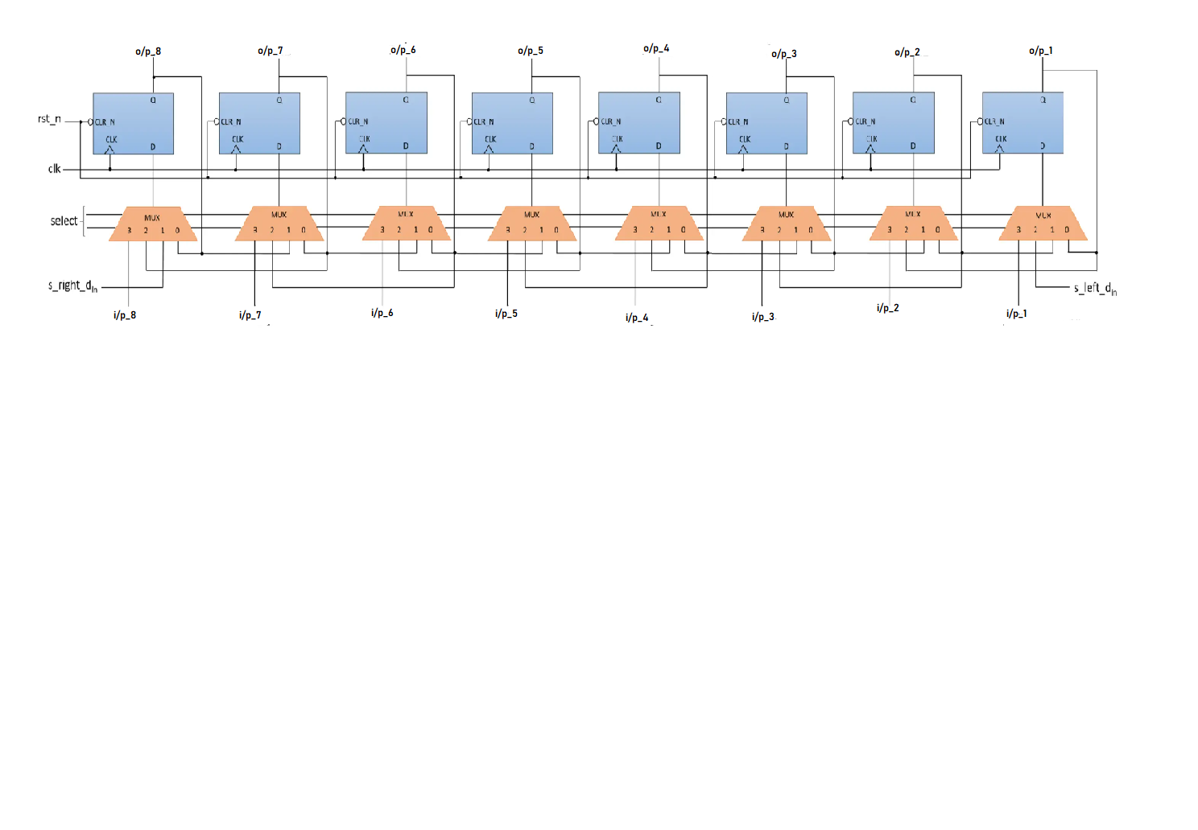
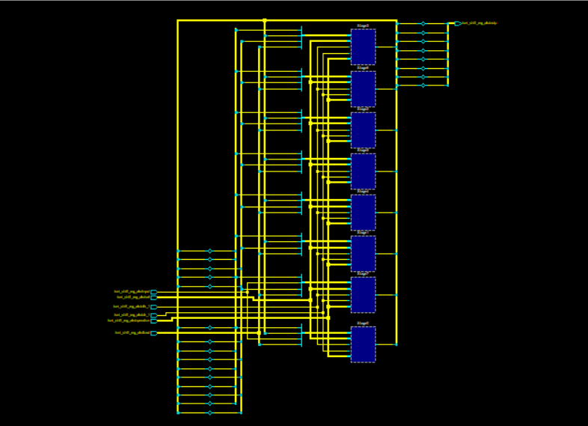

2.2 Logical Operations:
2.2.1 AND LOGIC
An AND gate is a basic logic gate in digital electronics. The AND gate has two or more inputs and a single output. The output of an AND gate is "true" (or high) only when all of its inputs are also "true" (or high).
Truth Table of AND Gate is given below,
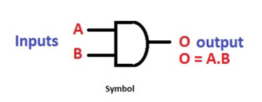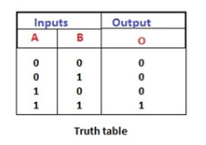

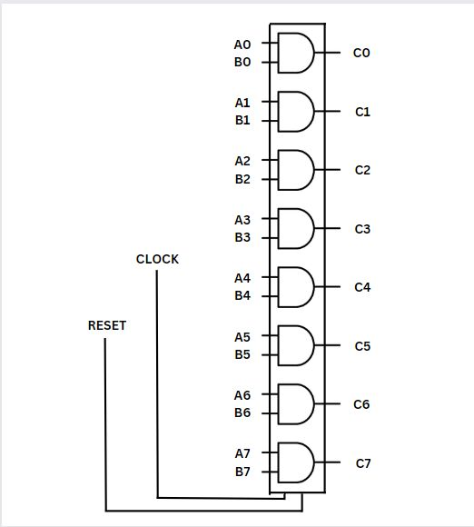
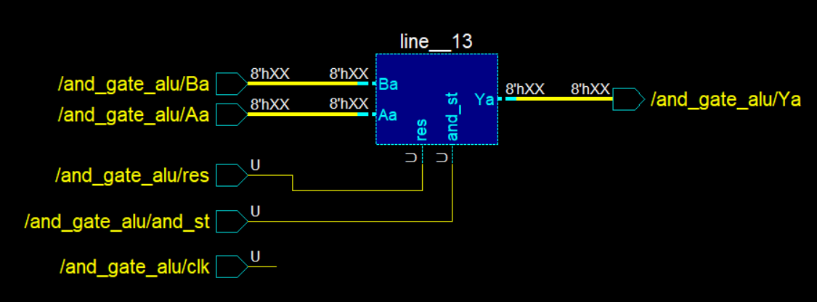
2.2.2 OR LOGIC
The OR gate is a basic logic gate that performs a logical OR operation. It has two or more input signals and produces an output signal based on the logical OR operation of those inputs. The output is 1 if at least one of the inputs is 1. If both inputs are 0, then the output is 0.
Truth Table of OR Gate is given below,
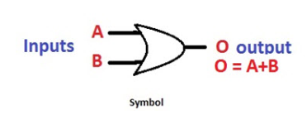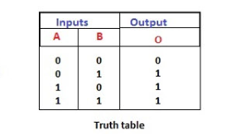
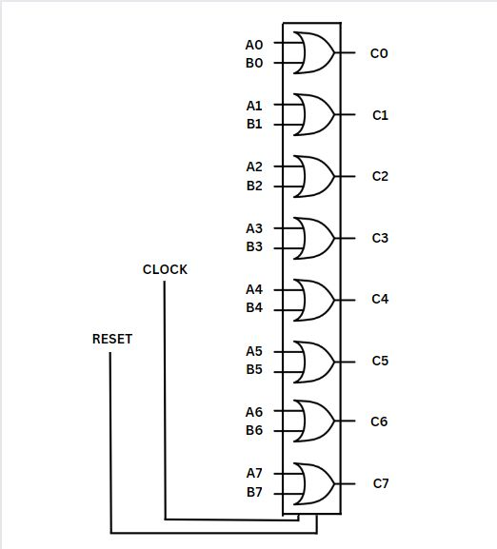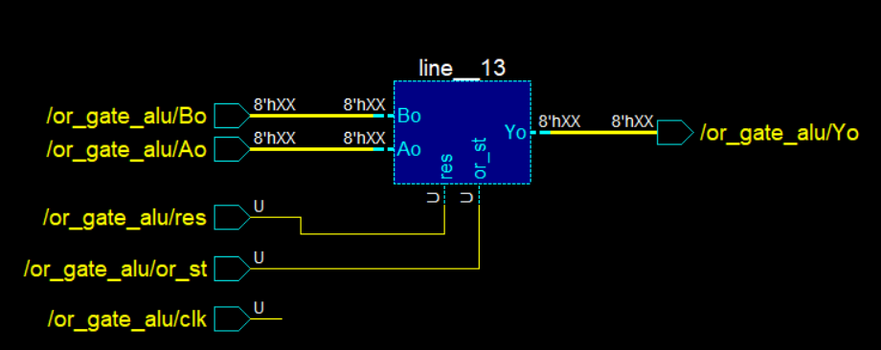
2.2.3 NOT LOGIC
A NOT gate, also known as an inverter, is a fundamental logic gate in digital electronics. It has one input and one output. The output of a NOT gate is the logical complement of its input, which means it produces the opposite logical state.
Truth Table of NOT Gate is given below,

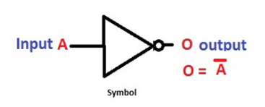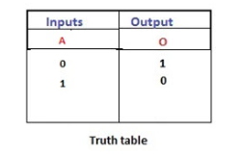
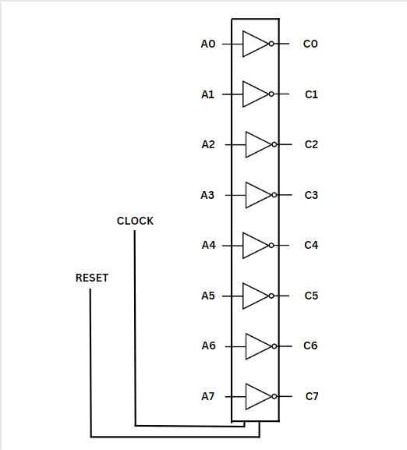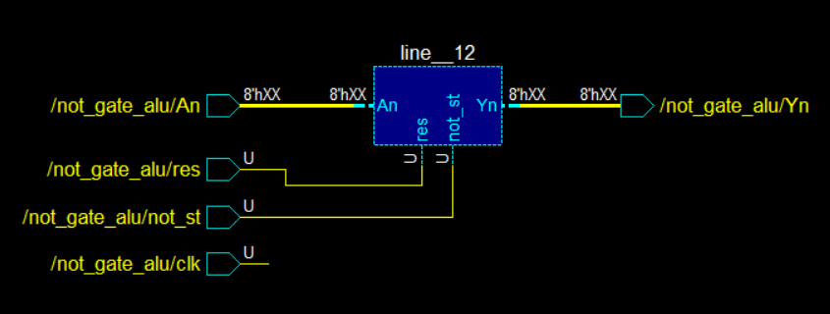
2.2.4 NAND LOGIC
A NAND gate, short for "NOT-AND" gate, is a fundamental logic gate in digital electronics. It is a type of universal gate, which means it can be used to create any other logic gate. The NAND gate has two or more inputs and one output. The output of a NAND gate is the logical negation (opposite) of the AND gate output.
Truth Table of NAND Gate is given below,
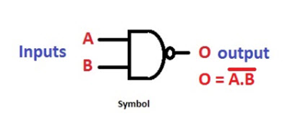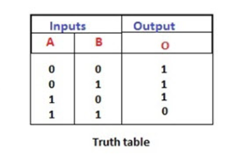
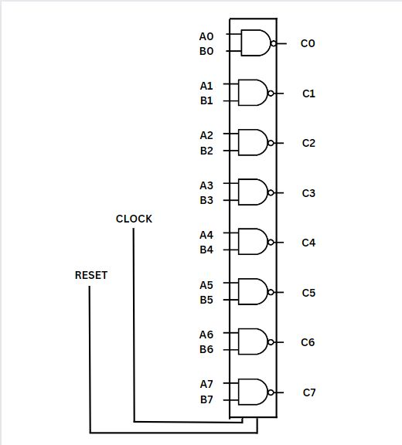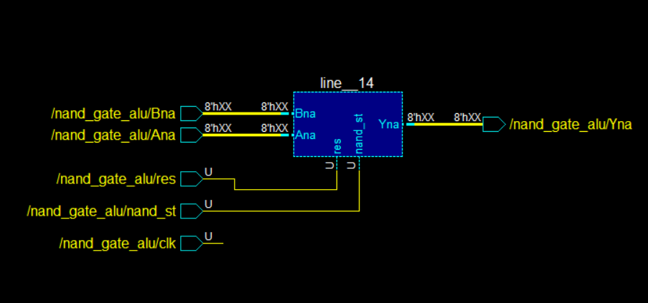
2.2.5 NOR LOGIC
A NOR gate is a logic gate that performs the logical NOR operation. It has two or more inputs and one output. The output of a NOR gate is high (1) only when all of its inputs are low (0); otherwise, the output is low (0). It is also an universal logic gate.
Truth Table of NOR Gate is given below,
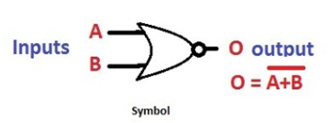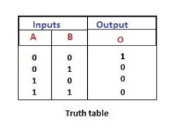
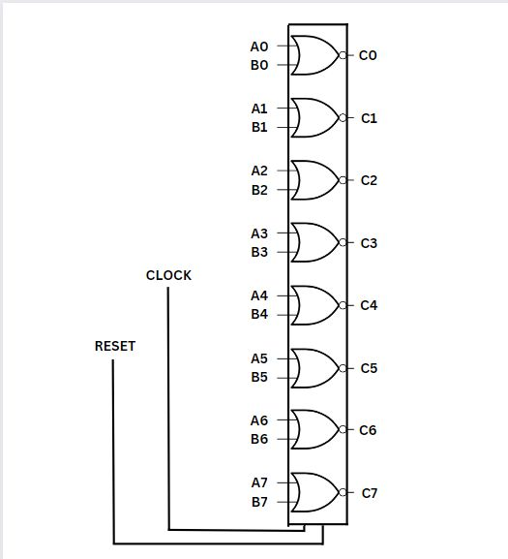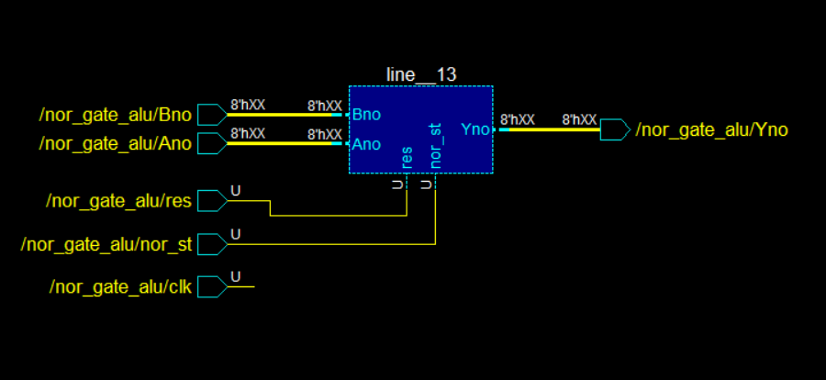

2.2.6 XOR LOGIC
An XOR gate, short for "exclusive OR gate," is a digital logic gate that performs an exclusive disjunction operation. It takes two binary inputs and produces a single binary output based on the following rule:
The XOR gate outputs "1" if the inputs are different (one input is true and the other is false), and "0" if the inputs are the same (both true or both false).
Truth Table of XOR Gate is given below,
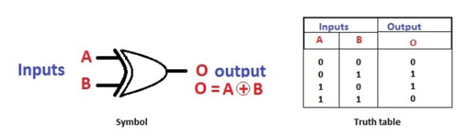
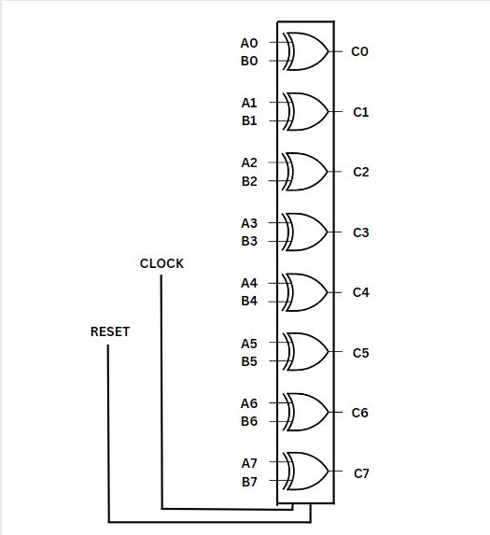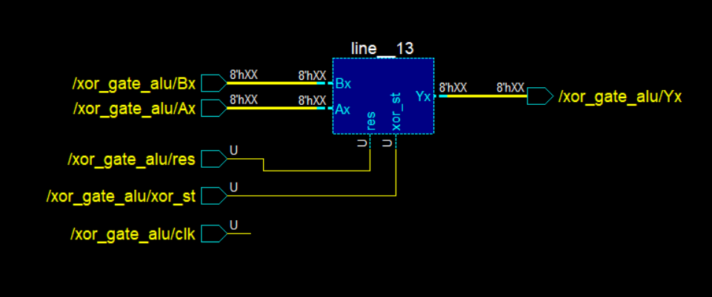
2.2.7 XNOR LOGIC
An XNOR gate, short for Exclusive-NOR gate, is a digital logic gate that produces a high output (usually represented as 1) only when the number of high inputs is even. In other words, it gives a high output if the number of high inputs is either zero or even. An XNOR gate can have two input and one output.
Truth Table of XNOR Gate is given below,
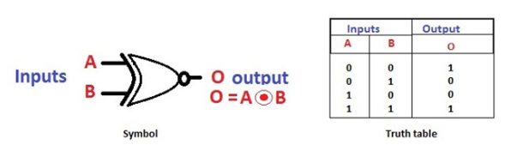
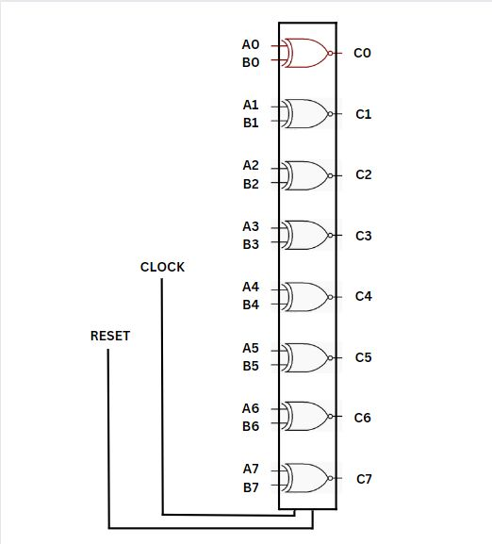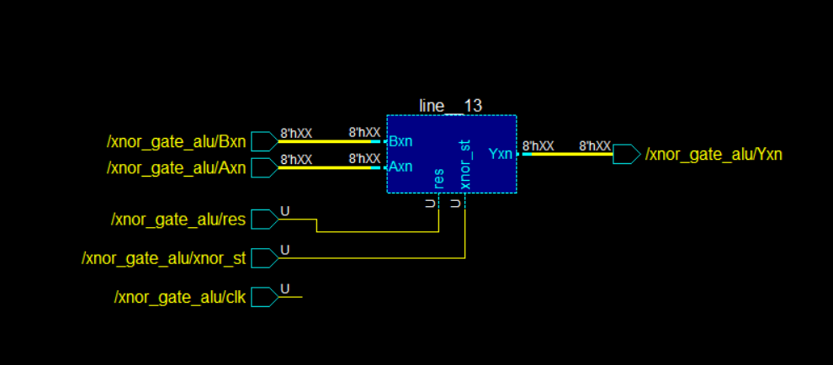

2.2.8 BUFFER LOGIC
A buffer gate, in digital electronics, is a logic gate that is used to isolate or amplify an input signal. It has a single input and a single output. The output of a buffer gate is an exact replica of its input. The buffer gate is also known as a unity gain buffer because it has a gain of 1. It does not perform any logical operation or inversion on the input signal; it simply reproduces the input signal at the output.
Truth Table of Buffer Gate is given below,
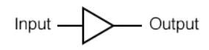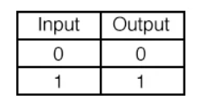

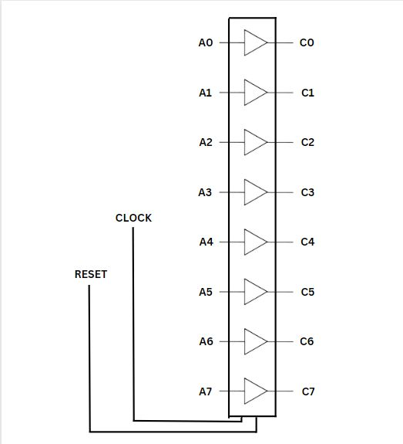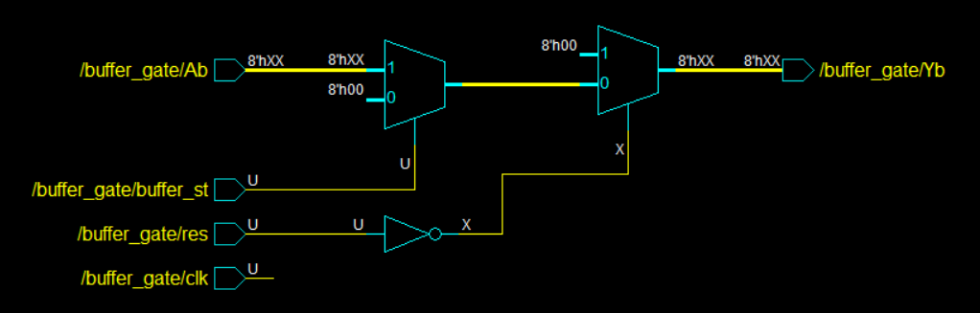

  - Struction of DECODER
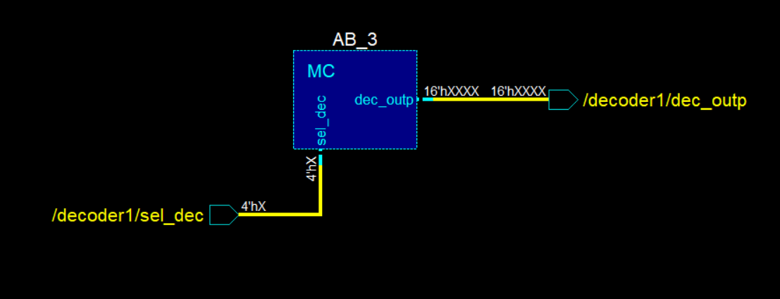
  - Structure of ALU

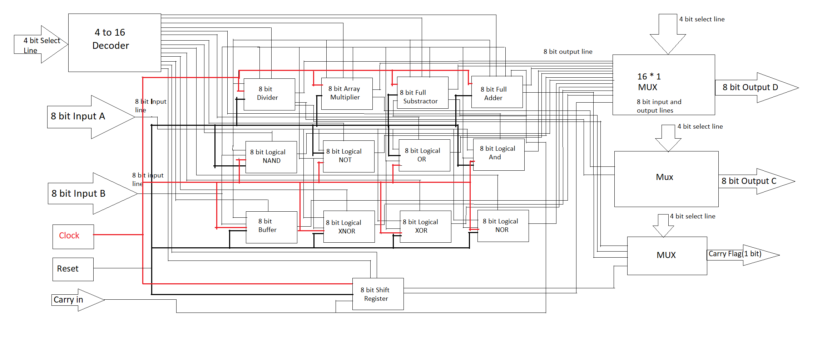
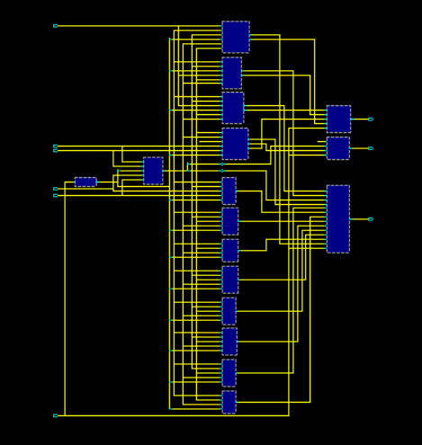

4. Codes Of Operations
Arithmetic Operations
0 - Addition
1 - Subtraction
2 - Multiplication
3 - Division
4 - Shift Right
5 - Shift Left
Logical Operations
8 - AND Logic D - XOR Logic
9 - OR Logic E – XNOR Logic
A - NOT Logic F – BUFFER Logic
B - NAND Logic
C - NOR Logic
5. Results Of Operations
5.1 ADDITION
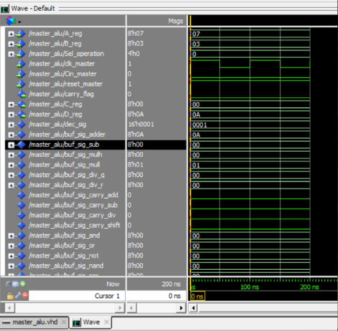
A - 00000111 (7)
B - 00000011 (3)
-----------------------
D - 00001010
(10 or 0A H)

5.2 Subtraction
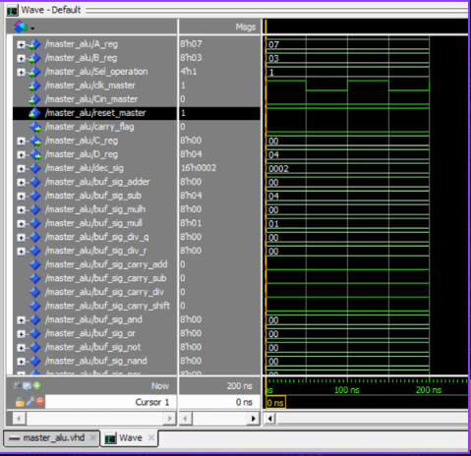
A - 00000111 (7)
B - 00000011 (3)
-----------------------
D - 00000100 (4)
5.3 Multiplication
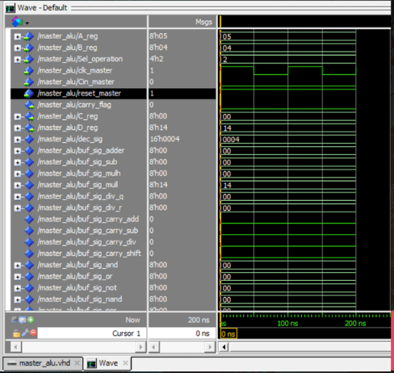
A - 00000101 (5)
B - 00000101 (4)
-----------------------
D - 00010100
(20 or 14 H)

5.4 Division
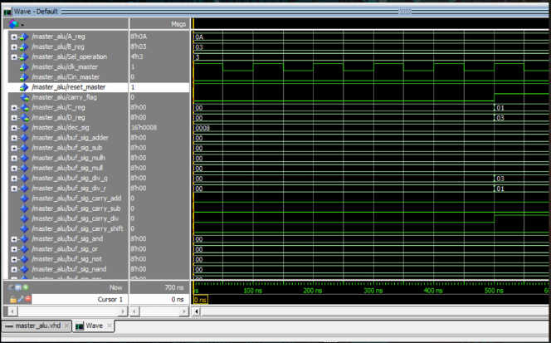
A - 00001010 (10 or 0A H)
B - 00000011 (3)
----------------------------------------
C - 00000001 (1) (Remainder)
D - 00000011 (3) (Quotient)

5.5 Shift Right
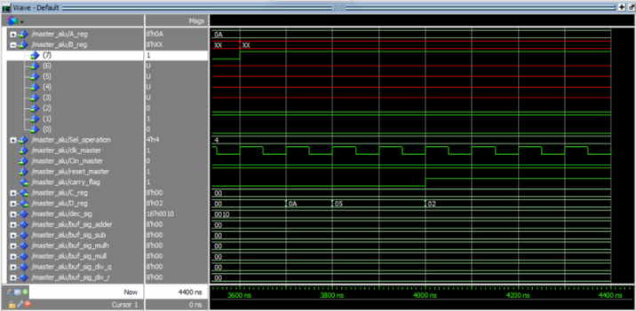
A - 00001010 (10 or 0A H)
B(2) - 0, B(1) - 1, B(0) - 0 = 2 times Right Shift

1st Shift - 00000101 (5 or 5 H)
2nd Shift - 00000010 (2 or 2 H)

5.6 Shift Left
A - 00001010 (10 or 0A H)
B(2) - 0, B(1) - 1, B(0) - 1 = 3 times Left Shift

1st Shift - 00010100 (20 or 14 H)
2nd Shift - 00101000 (40 or 28 H)
3rd Shift - 01010000 (80 or 50 H)
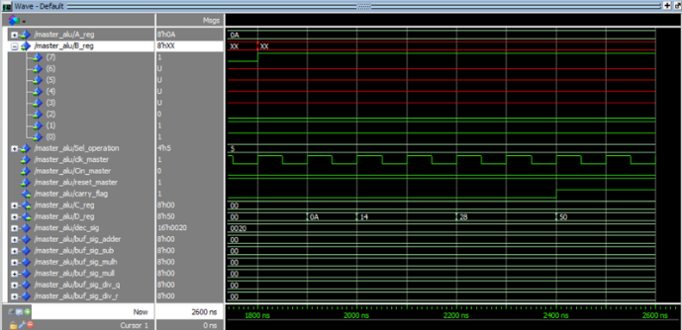

5.7 And Logic
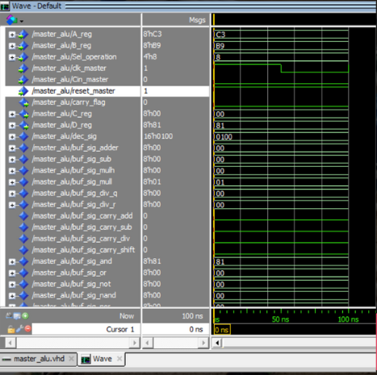
A - 11000011 (C3 H)
B - 10111001 (B9 H)
-----------------------
D - 10000001 (81 H)

5.8 Or Logic
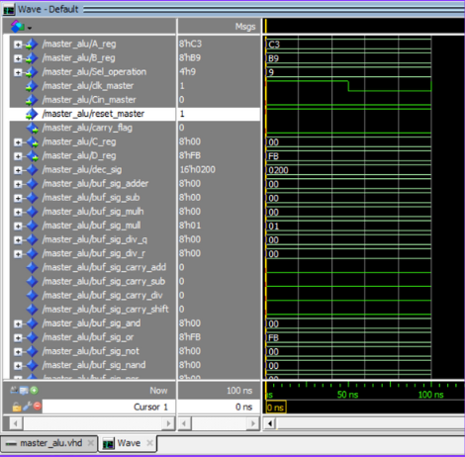
A - 11000011 (C3 H)
B - 10111001 (B9 H)
-----------------------
D - 11111011 (FB H)

5.9 Not Logic
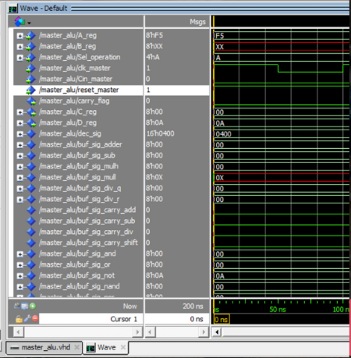
A - 11110101 (F5 H)
-----------------------
D - 00001010 (0A H)

5.10 Nand Logic
A - 11000011 (C3 H)
B - 10111001 (B9 H)
-----------------------
D - 01111110 (7E H)
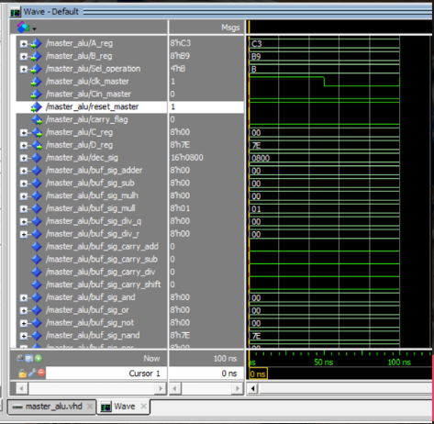

5.11 Nor Logic
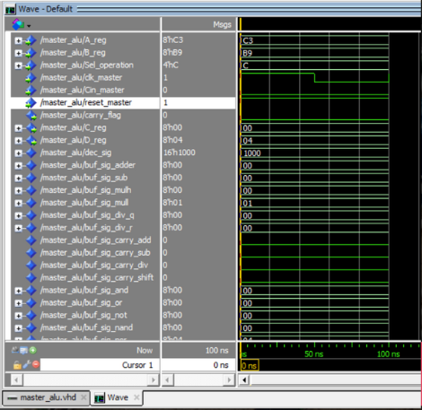
A - 11000011 (C3 H)
B - 10111001 (B9 H)
-----------------------
D - 00000100 (04 H)

5.12 Xor Gate
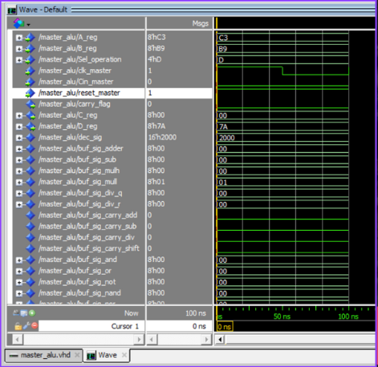
A - 11000011 (C3 H)
B - 10111001 (B9 H)
-----------------------
D - 01111010 (7A H)

5.13 Xnor Logic
A - 11000011 (C3 H)
B - 10111001 (B9 H)
-----------------------
D - 10000101 (85 H)

5.14 Buffer Logic
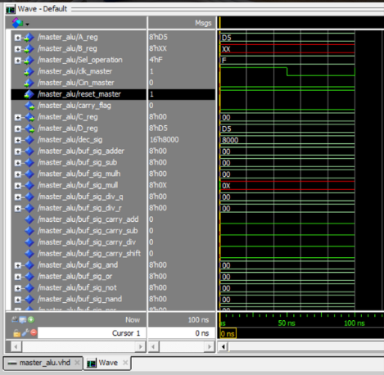
A - 11010101 (D5 H)
-----------------------
D - 11010101 (D5 H)

6. Future Work
FPGA Implementation
Can be upgraded to ALU of higher bits
Operatrions like Circular Shifting can be included.

7. Conclusion
In conclusion, the 8-bit Arithmetic Logic Unit (ALU) is a fundamental component of a computer's central processing unit (CPU). It is responsible for performing arithmetic and logical operations on 8-bit binary numbers, allowing the CPU to execute complex calculations and make decisions based on logical conditions.
The ALU's ability to perform these operations is crucial for tasks such as data manipulation, numerical computations, and decision-making within a computer system. By combining the results of these operations, the ALU can facilitate more complex operations.
Moreover, the 8-bit ALU can be extended to larger word sizes, such as 16-bit, 32-bit, or even 64-bit ALUs, depending on the requirements of the CPU architecture. Increasing the word size allows for more extensive calculations and higher precision in numerical operations.

8. Referrences
VHDL Primer by J.Bhasker (Book)
VHDL Programming by Example by Douglas L. Perry (Book)
https://www.fwdskillzone.com/universal_shift_register.html#:~:text=Universal%20Shift%20Register%20is%20a,in%20parallel%20out%20(PIPO.)
https://circuitdigest.com/microcontroller-projects/implementation-of-basic-logic-gates-using-vhdl-in-modelsim

